CASE STUDY -1 University Scholarship Allocation
1. Problem Statement
Develop a system to check scholarship applicants using aggregate marks, subject-wise minimum marks, attendance and family income. Eligible students are ranked and scholarships are awarded within a fixed quota.
2. Objectives
Validate each applicant against academic, attendance and income rules.
Calculate aggregate percentage and identify eligible applicants.
Rank eligible applicants using marks, then attendance, then lower family income.
Award scholarships only up to the available quota.
3. Assumptions
There are three subjects, each out of 100 marks.
Minimum aggregate is 75%, each subject must be at least 60, attendance must be at least 85%, and annual family income must not exceed ₹2,50,000.
The scholarship quota is 2 students.
Ties are resolved by higher attendance and then lower family income.
4. Algorithm
Start and create applicant records.
For each applicant, calculate total and percentage.
Check subject marks, percentage, attendance and income.
Store eligible applicants in a list.
Sort eligible applicants by percentage, attendance and income.
Award scholarships up to the quota and display the result.
5. Flowchart
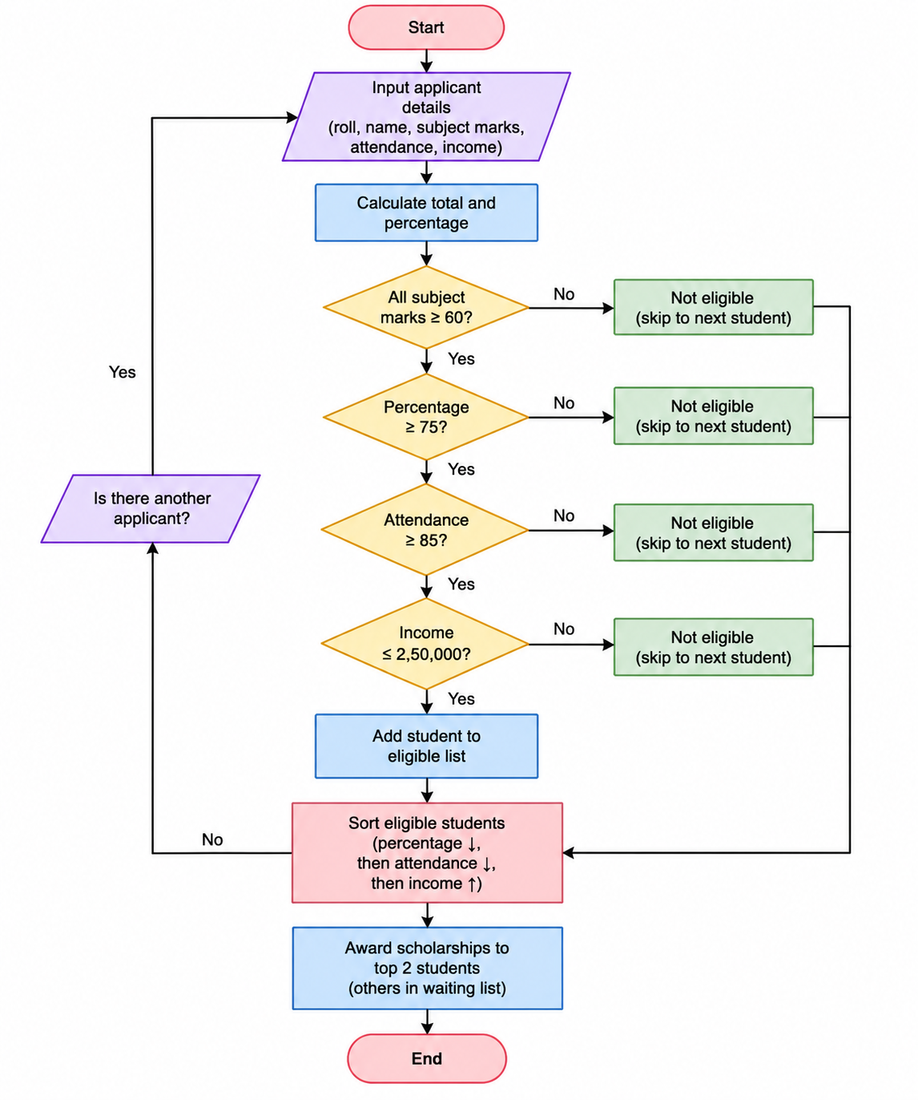
6. Pseudocode
START
Start and create applicant records.
For each applicant, calculate total and percentage.
Check subject marks, percentage, attendance and income.
Store eligible applicants in a list.
Sort eligible applicants by percentage, attendance and income.
Award scholarships up to the quota and display the result.
Display result
STOP
7. Test Cases
Input / Record | Expected Result
A101 | Eligible; ranked first
A103 | Rejected because one subject is below 60
A104 | Eligible; ranked second
8. Output screenshot
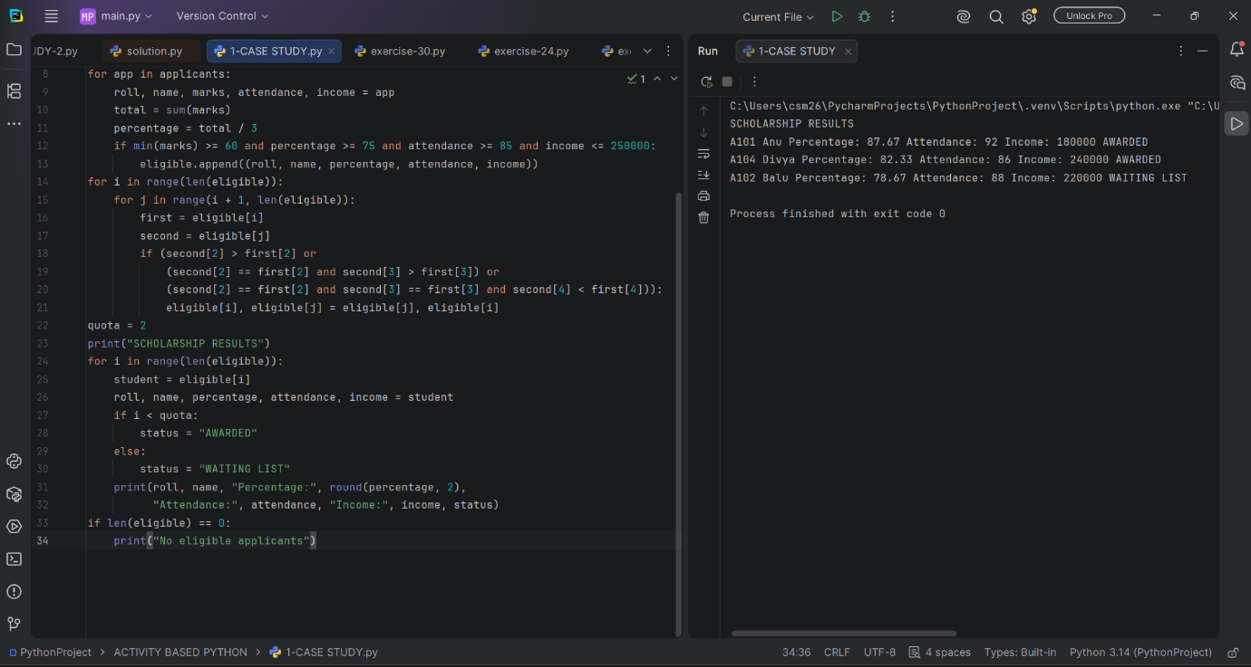
9. Conclusion
The program checks all scholarship conditions, ranks eligible applicants and awards scholarships within the fixed quota.

